Great Cubicuboctahedron

Definition
# Source: AI Source: Provided by: [Data Path: Persons Table -> ID Column: 1, Name_En Column: Motasem Essam] -> From: [ChatGPT] on [7/25/2026]
The Great Cubicuboctahedron is a non-convex uniform star polyhedron composed of 20 regular polygonal faces: 8 equilateral triangles, 6 squares, and 6 regular octagrams (star octagons).
It is characterized by intersecting faces, a crossed vertex arrangement, and full octahedral symmetry. It is also known as the Small Ditrigonal Icosidodecahedron in some naming systems, although this alternative name is associated with its uniform-polyhedron classification.
Its classification identifiers include:
- Uniform Polyhedron Index: U₁₄
- Coxeter Index: C₅₀
- Wenninger Index: W₇₇
- Bowers Acronym: Gocco
Its Wythoff symbol is:
$$\boxed{3 4∣\frac{4}{3}}$$

Geometric Representation
# Source: AI Source: Provided by: [Data Path: Persons Table -> ID Column: 1, Name_En Column: Motasem Essam] -> From: [ChatGPT] on [7/25/2026]
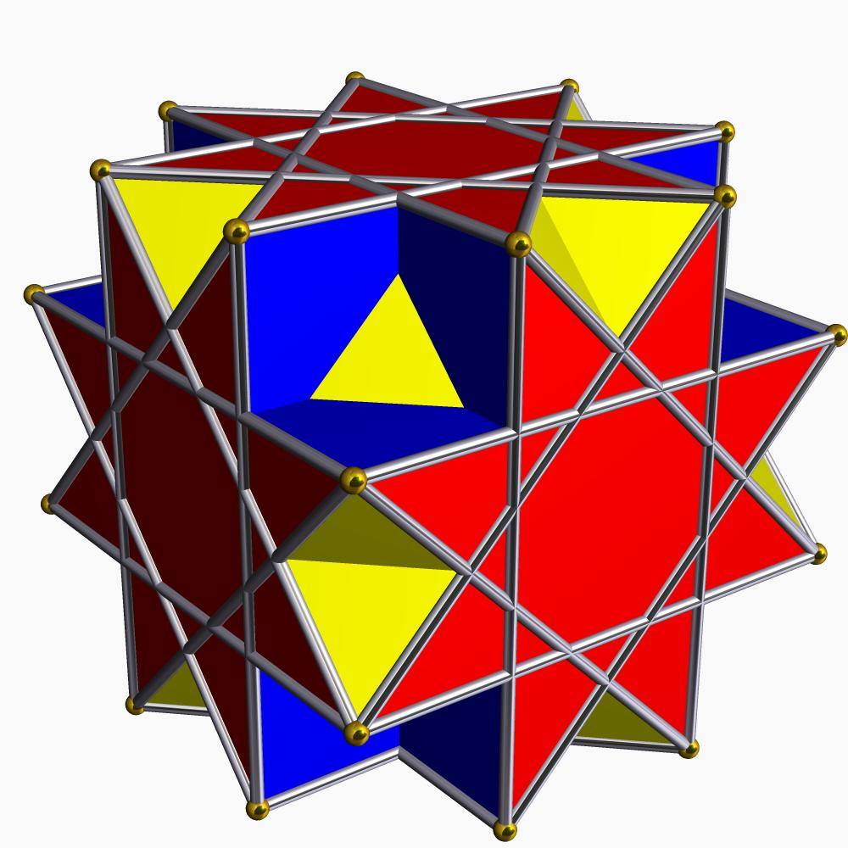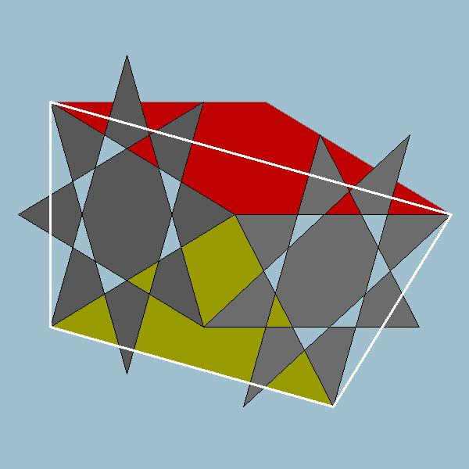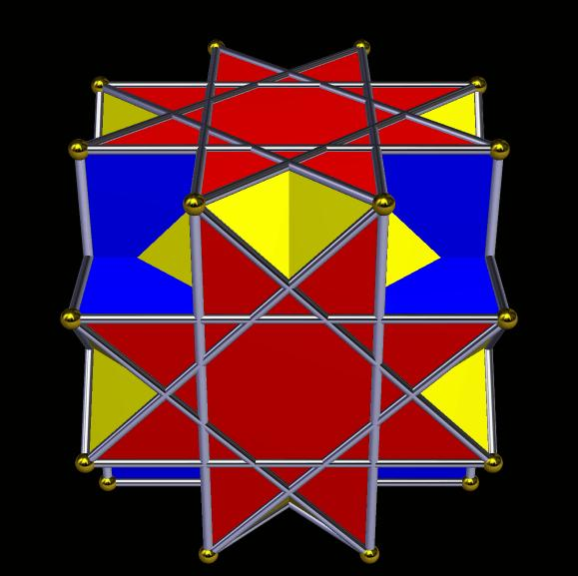

Geometric Structure
# Source: AI Source: Provided by: [Data Path: Persons Table -> ID Column: 1, Name_En Column: Motasem Essam] -> From: [ChatGPT] on [7/25/2026]
The Great Cubicuboctahedron consists of three types of regular polygonal faces:
- Triangular faces: 8 equilateral triangles.
- Square faces: 6 regular squares.
- Octagrammic faces: 6 regular octagrams, represented by the star-polygon notation $\{8/3\}$.
Its main structural characteristics include:
- All edges have equal lengths.
- All vertices are equivalent under its symmetry group.
- Its faces intersect in three-dimensional space.
- Its octagrammic faces are self-intersecting star polygons.
- Its square and octagrammic faces are parallel to corresponding face planes of a cube.
- Its triangular faces are parallel to corresponding face planes of an octahedron.
The Great Cubicuboctahedron is a faceting of the cube and has the same vertex-edge skeleton as the small rhombicuboctahedron.

Mathematical Properties
# Source: AI Source: Provided by: [Data Path: Persons Table -> ID Column: 1, Name_En Column: Motasem Essam] -> From: [ChatGPT] on [7/25/2026]
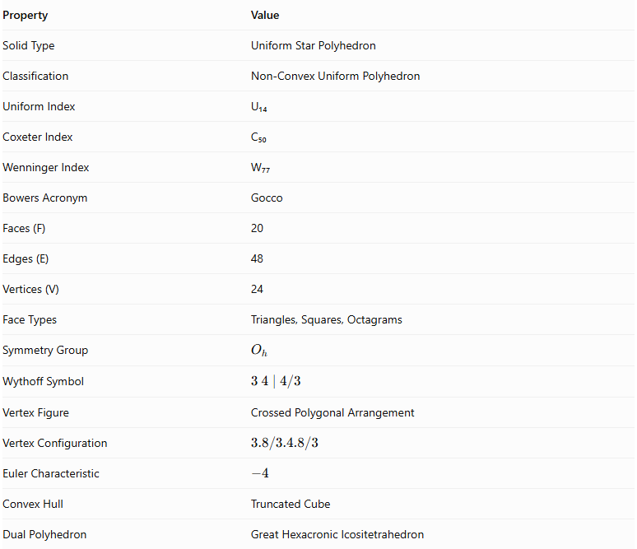
Property | Value
Solid Type | Uniform Star Polyhedron
Classification | Non-Convex Uniform Polyhedron
Uniform Index | U₁₄
Coxeter Index | C₅₀
Wenninger Index | W₇₇
Bowers Acronym | Gocco
Faces (F) | 20
Edges (E) | 48
Vertices (V) | 24
Face Types | Triangles, Squares, Octagrams
Symmetry Group | $$O_{h}$$
Wythoff Symbol | $$3 4∣4/3$$
Vertex Figure | Crossed Polygonal Arrangement
Vertex Configuration | $$3.8/3.4.8/3$$
Euler Characteristic | $$-4$$
Convex Hull | Truncated Cube
Dual Polyhedron | Great Hexacronic Icositetrahedron

Face Composition
# Source: AI Source: Provided by: [Data Path: Persons Table -> ID Column: 1, Name_En Column: Motasem Essam] -> From: [ChatGPT] on [7/25/2026]
The Great Cubicuboctahedron has 20 faces distributed among three polygon types.
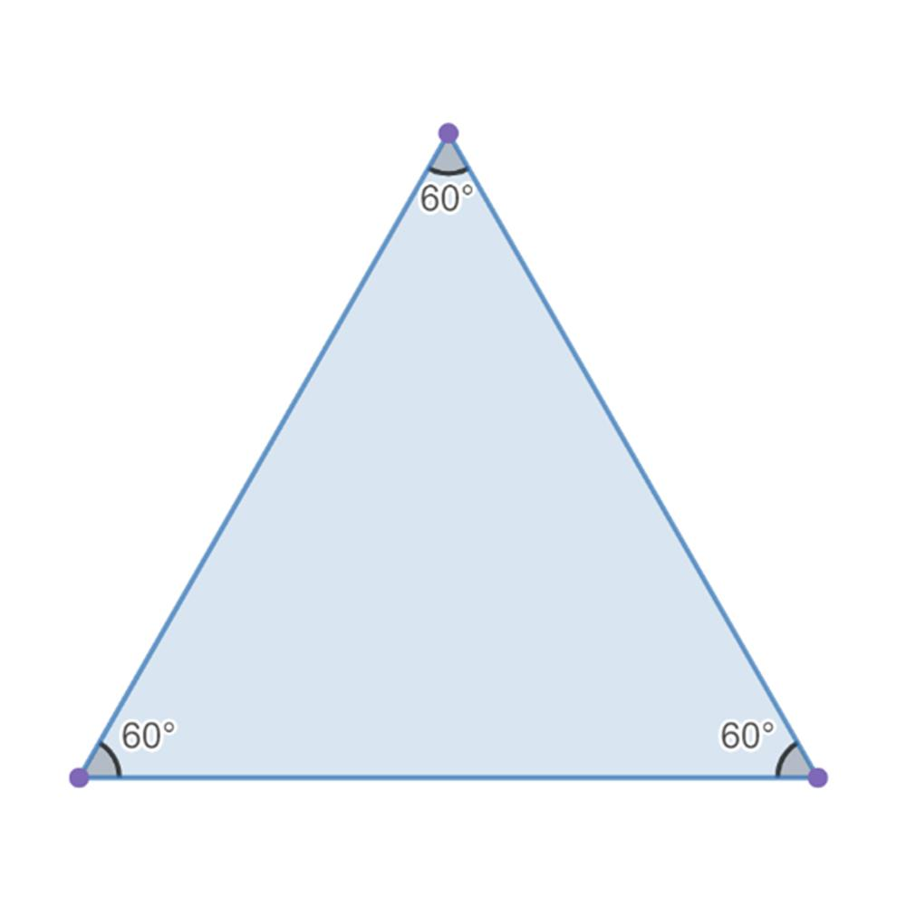
Equilateral Triangles
8
Three equal sides and three 60° angles.
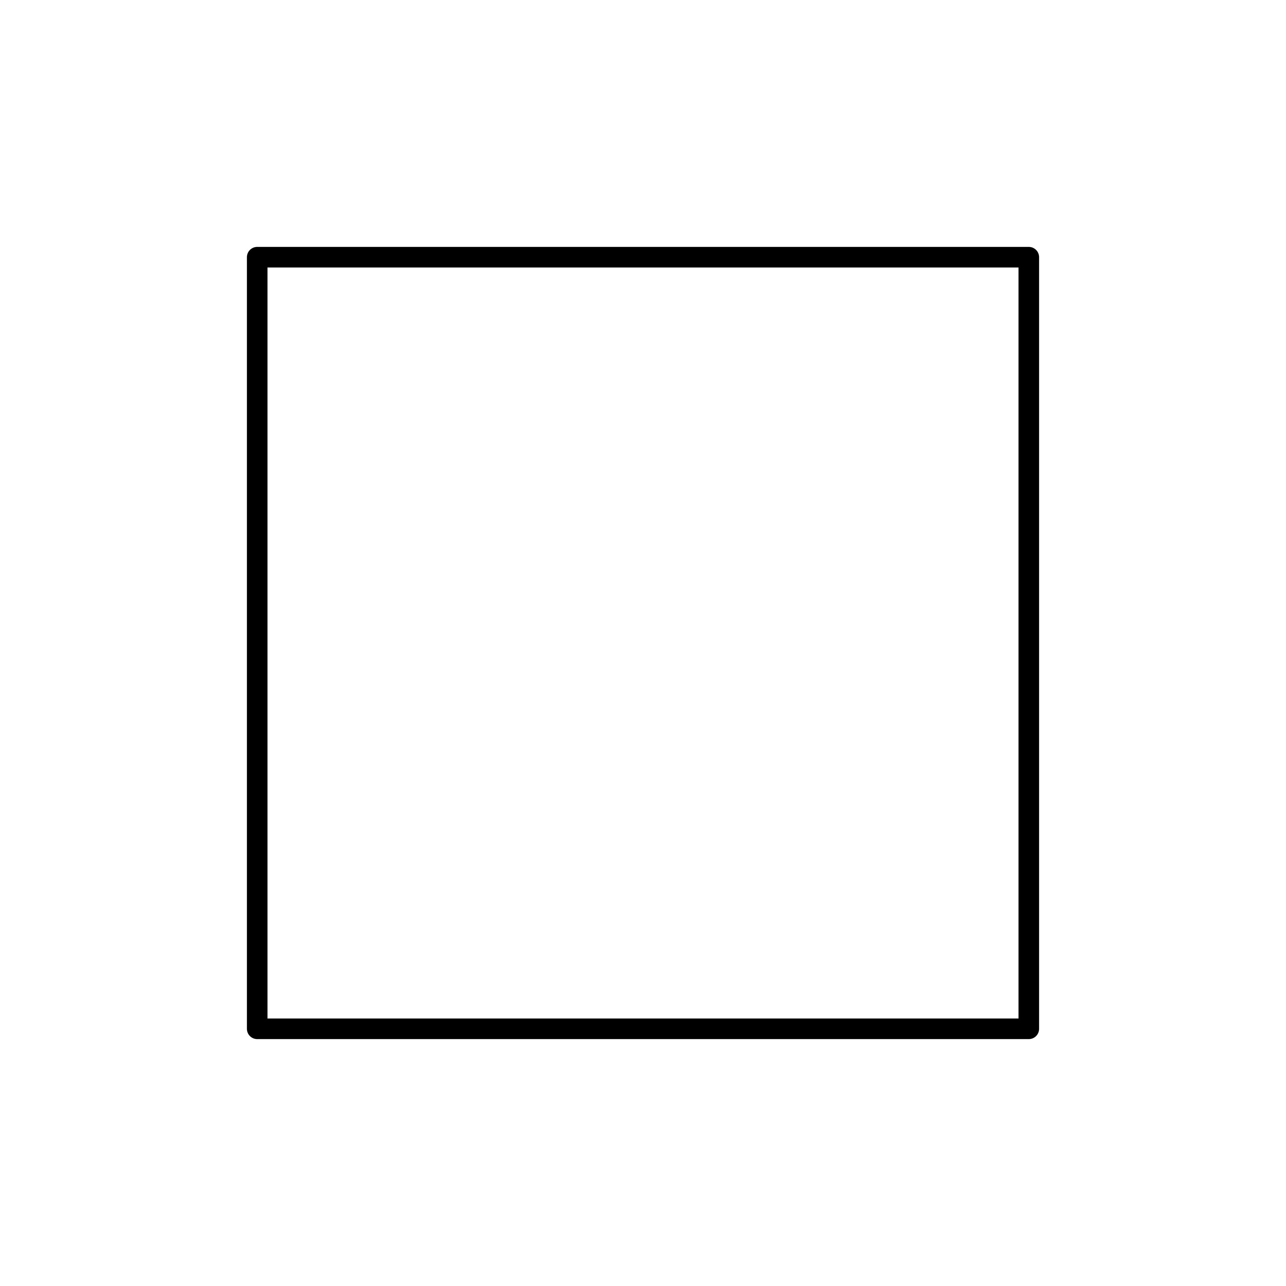
Squares
6
Four equal sides and four 90° angles.
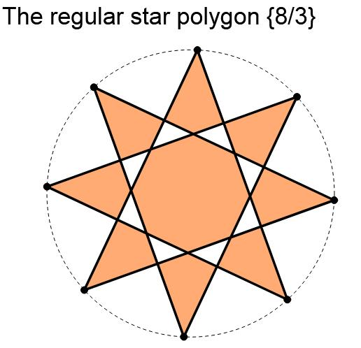
Regular Octagrams
6
Eight vertices connected with a step of three positions.
The face composition is represented by:
$$\boxed{8\{3\}+6\{4\}+6\{\frac{8}{3}\}}$$
Where:
- $\{3\}$ represents an equilateral triangle.
- $\{4\}$ represents a square.
- $\{8/3\}$ represents a regular octagram.
Understanding the octagram: The notation $\{8/3\}$ means that eight vertices are arranged around a circle, and each vertex is connected to the vertex three positions ahead. This creates a self-intersecting star polygon.

Vertex Configuration
# Source: AI Source: Provided by: [Data Path: Persons Table -> ID Column: 1, Name_En Column: Motasem Essam] -> From: [ChatGPT] on [7/25/2026]
The Great Cubicuboctahedron has 24 equivalent vertices.
Its vertex configuration is:
$$\boxed{3.\frac{8}{3}.4.\frac{8}{3}}$$
This describes the arrangement of faces around each vertex:
- An equilateral triangular face.
- An octagrammic face.
- A square face.
- Another octagrammic face.
The vertex arrangement is crossed and non-convex because the octagrammic faces introduce star-shaped intersections.

Construction
# Source: AI Source: Provided by: [Data Path: Persons Table -> ID Column: 1, Name_En Column: Motasem Essam] -> From: [ChatGPT] on [7/25/2026]
The Great Cubicuboctahedron can be constructed as a faceting of a cube.
A faceting retains a polyhedron's vertex set while changing its edges and faces.
Its construction can be understood through these stages:
- Begin with the eight vertices of a cube and the additional vertex positions needed for its 24-vertex arrangement.
- Arrange 8 equilateral triangular faces in octahedral orientations.
- Construct 6 square faces parallel to the corresponding cube faces.
- Construct 6 regular octagrammic faces using the $\{8/3\}$ star-polygon arrangement.
- Connect the faces according to the uniform arrangement.
- Allow the faces to intersect, producing the non-convex star polyhedron.
The resulting solid has 20 faces, 48 edges, and 24 vertices.

Geometric Dimensions and Formulas
# Source: AI Source: Provided by: [Data Path: Persons Table -> ID Column: 1, Name_En Column: Motasem Essam] -> From: [ChatGPT] on [7/25/2026]
Let:
- $a$ = common edge length.
- $R$ = circumradius.
- $A_{3}$ = area of one equilateral triangular face.
- $A_{4}$ = area of one square face.
Equilateral triangular face area:
$$A_{3}=\frac{\sqrt{3}}{4}a^{2}$$
Square face area:
$$A_{4}=a^{2}$$
Circumradius:
For a Great Cubicuboctahedron with unit edge length:
$$R=\frac{1}{2}\sqrt{5-2\sqrt{2}}$$
For a general edge length:
$$\boxed{R=\frac{a}{2}\sqrt{5-2\sqrt{2}}}$$
The octagrammic faces require special care when calculating area because their edges intersect. Their signed polygon area and the sum of the individual visible triangular regions are not necessarily the same.
A single ordinary surface-area or volume formula should therefore specify the convention used for the self-intersecting faces and solid.

Euler Characteristic
# Source: AI Source: Provided by: [Data Path: Persons Table -> ID Column: 1, Name_En Column: Motasem Essam] -> From: [ChatGPT] on [7/25/2026]
Using the conventional numbers of vertices, edges, and faces:
$$χ=V-E+F$$
Substituting:
$$χ=24-48+20$$
$$\boxed{χ=-4}$$
For an orientable surface:
$$χ=2-2g$$
Therefore:
$$-4=2-2g$$
$$\boxed{g=3}$$
The corresponding abstract surface has genus 3. This is a topological interpretation of its combinatorial structure, not a description of an ordinary convex solid.

Symmetry
# Source: AI Source: Provided by: [Data Path: Persons Table -> ID Column: 1, Name_En Column: Motasem Essam] -> From: [ChatGPT] on [7/25/2026]
The Great Cubicuboctahedron has full octahedral symmetry.
Its symmetry group is:
$$\boxed{O_{h}}$$
Its symmetry includes:
- Rotational symmetry associated with the cube and octahedron.
- Reflection symmetry.
- Inversion symmetry.
- Equivalent vertices under its symmetry transformations.
This symmetry ensures that every vertex has the same local face arrangement.

Constructing a Great Cubicuboctahedron

Geometric Instruments
# Source: AI Source: Provided by: [Data Path: Persons Table -> ID Column: 1, Name_En Column: Motasem Essam] -> From: [ChatGPT] on [7/25/2026]
The following instruments can be used to construct the Great Cubicuboctahedron and its geometric framework.
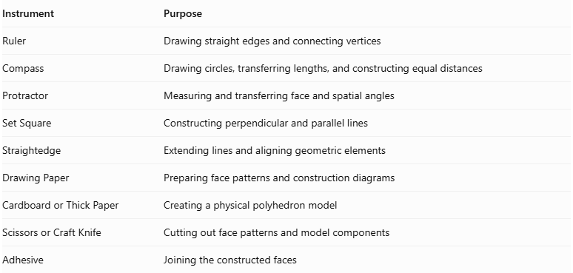
Instrument | Purpose
Ruler | Drawing straight edges and connecting vertices
Compass | Drawing circles, transferring lengths, and constructing equal distances
Protractor | Measuring and transferring face and spatial angles
Set Square | Constructing perpendicular and parallel lines
Straightedge | Extending lines and aligning geometric elements
Drawing Paper | Preparing face patterns and construction diagrams
Cardboard or Thick Paper | Creating a physical polyhedron model
Scissors or Craft Knife | Cutting out face patterns and model components
Adhesive | Joining the constructed faces

Instrument-Based Construction Procedures

Method 1: Construction from a Truncated Cube Vertex Framework
# Source: AI Source: Provided by: [Data Path: Persons Table -> ID Column: 1, Name_En Column: Motasem Essam] -> From: [ChatGPT] on [7/25/2026]
This method uses a truncated cube as the starting geometric framework. The truncated cube and Great Cubicuboctahedron share the same 24 vertices, although their face and edge connections differ.
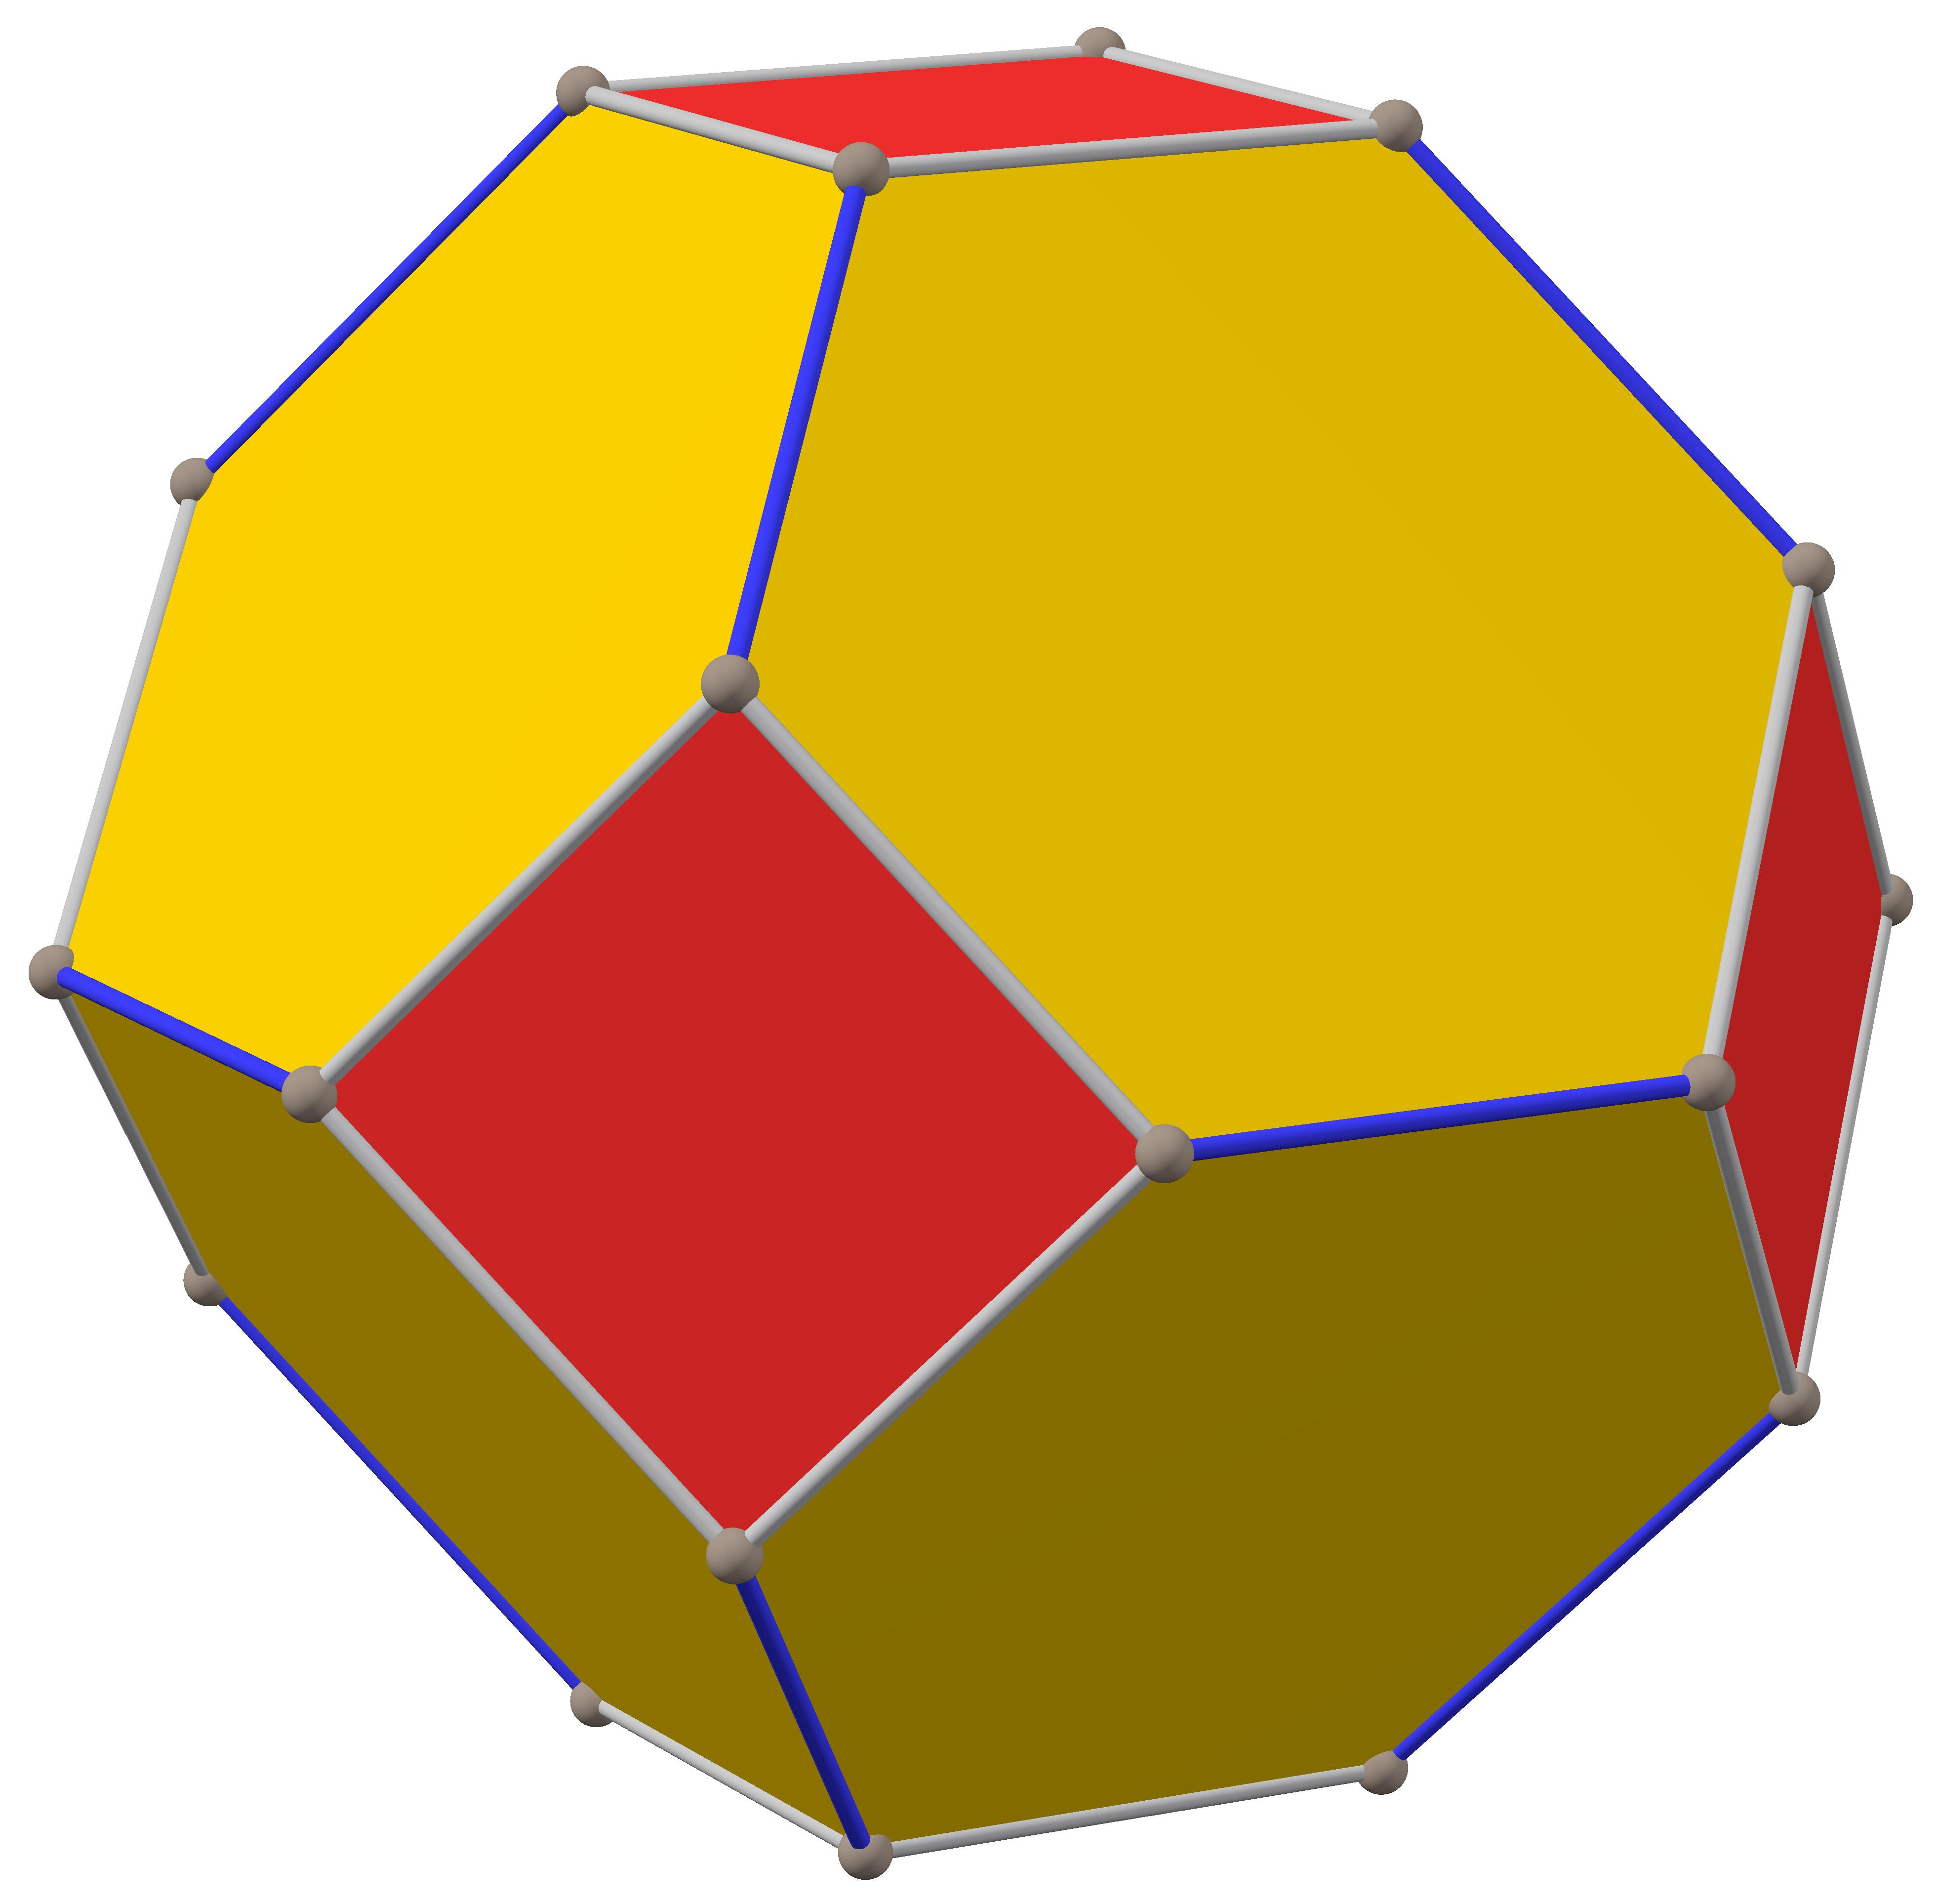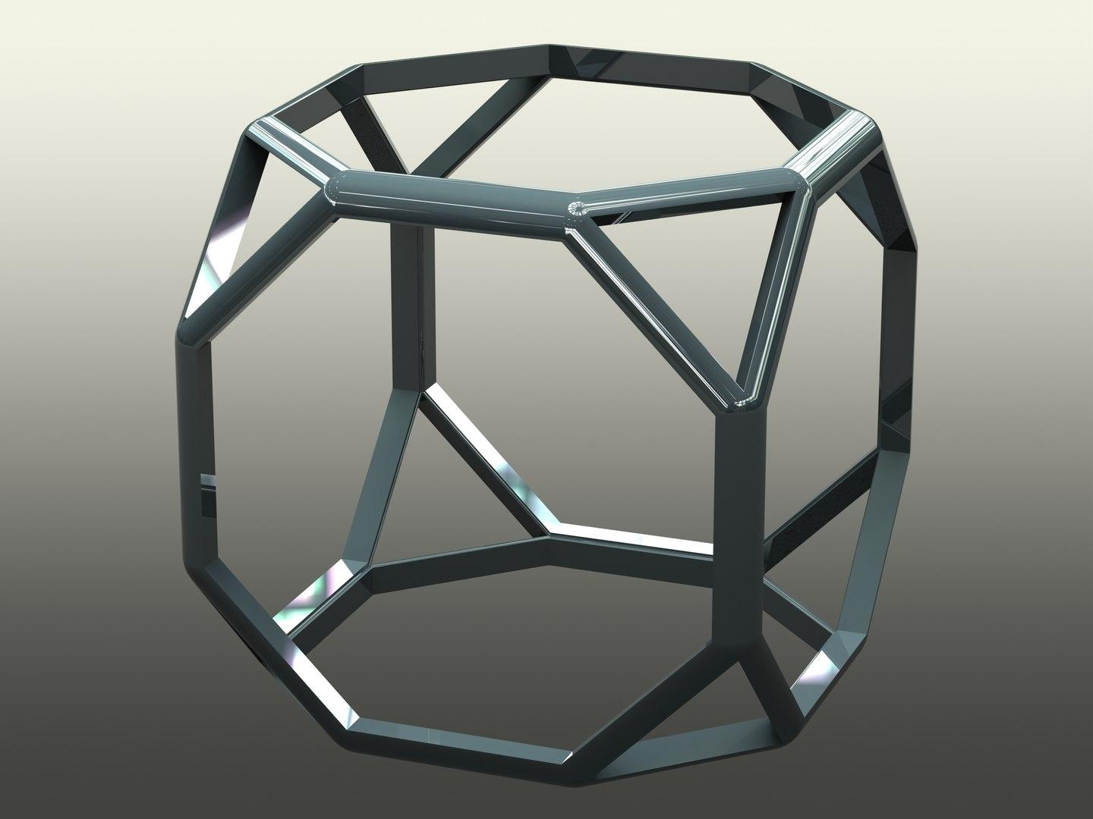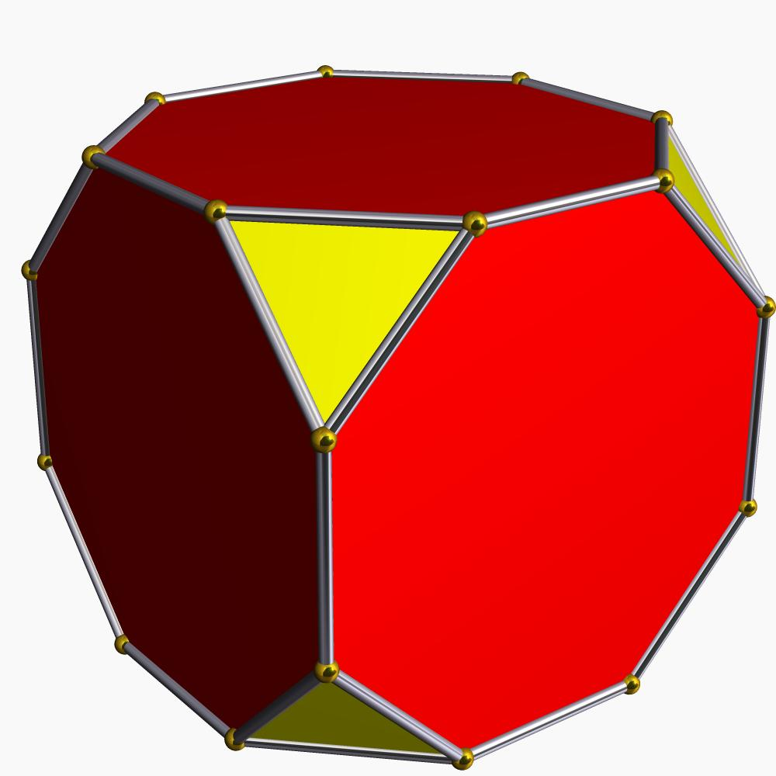
Step 1: Construct a Cube
- Draw a cube using a ruler and set square.
- Ensure that its edges and faces are represented accurately.
- Mark the eight original vertices.
Step 2: Divide the Cube Edges
- Divide each cube edge into three equal parts using a ruler and compass.
- Mark the two division points on every edge.
- The resulting construction provides 24 points: two on each of the cube's 12 edges.
Step 3: Establish the Truncated Cube Framework
- Connect the marked points around the original cube corners to establish the truncated-cube vertex arrangement.
- Identify the positions of all 24 vertices.
- Retain these points as the framework for the Great Cubicuboctahedron.
Step 4: Identify the Triangular Face Groups
- Locate groups of three vertices that form equilateral triangles.
- Construct the 8 triangular faces.
- Check that each triangle has three equal edges.
Step 5: Construct the Square Face Groups
- Identify the six square face arrangements.
- Connect their four vertices in the correct order.
- Check their equal side lengths and right angles.
Step 6: Construct the Octagrammic Face Groups
- Identify the six remaining eight-vertex arrangements.
- Connect every vertex to the vertex three positions ahead in the cyclic sequence.
- This produces six regular octagrams with the polygon symbol $\{8/3\}$.
Step 7: Complete the Polyhedron
- Connect the face boundaries using the established 48-edge arrangement.
- Check that all 24 vertices are included.
- Distinguish the intersecting face regions from the external outline.
- Review the model from multiple viewing directions to verify its star-shaped structure.

Method 2: Construction Using Face Templates
# Source: AI Source: Provided by: [Data Path: Persons Table -> ID Column: 1, Name_En Column: Motasem Essam] -> From: [ChatGPT] on [7/25/2026]
This method is useful for making a physical paper or cardboard model.
Step 1: Prepare the Face Patterns
Construct three face templates:
- 8 equilateral triangles.
- 6 squares.
- 6 regular octagrams $\{8/3\}$.
Step 2: Construct the Octagrams
- Draw a regular octagon using a compass and protractor.
- Label its eight vertices in cyclic order.
- Connect each vertex to the vertex three positions ahead.
- Trace the resulting star polygon while preserving its eight equal edges.
Step 3: Establish the Common Edge Length
- Use the same edge length for all three face types.
- Verify the triangle, square, and octagram edge lengths with a compass.
- Ensure that all face templates use consistent measurements.
Step 4: Arrange the Faces
- Position the eight triangles, six squares, and six octagrams according to the Great Cubicuboctahedron's vertex configuration.
- Align the faces with the 24-vertex framework.
- Check that the arrangement preserves the required octahedral symmetry.
Step 5: Assemble the Model
- Cut out the face patterns.
- Join the corresponding edges using tabs or suitable connectors.
- Allow for the face intersections that occur in the non-convex structure.
- Inspect the completed model from different directions.
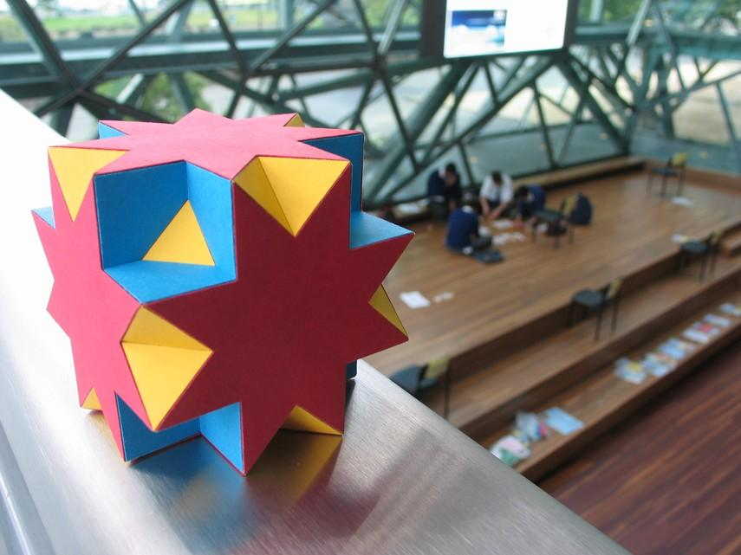

Relationship to Other Geometric Solids
# Source: AI Source: Provided by: [Data Path: Persons Table -> ID Column: 1, Name_En Column: Motasem Essam] -> From: [ChatGPT] on [7/25/2026]
Truncated Cube
The convex hull of the Great Cubicuboctahedron. It contains all 24 vertices within its convex boundary.
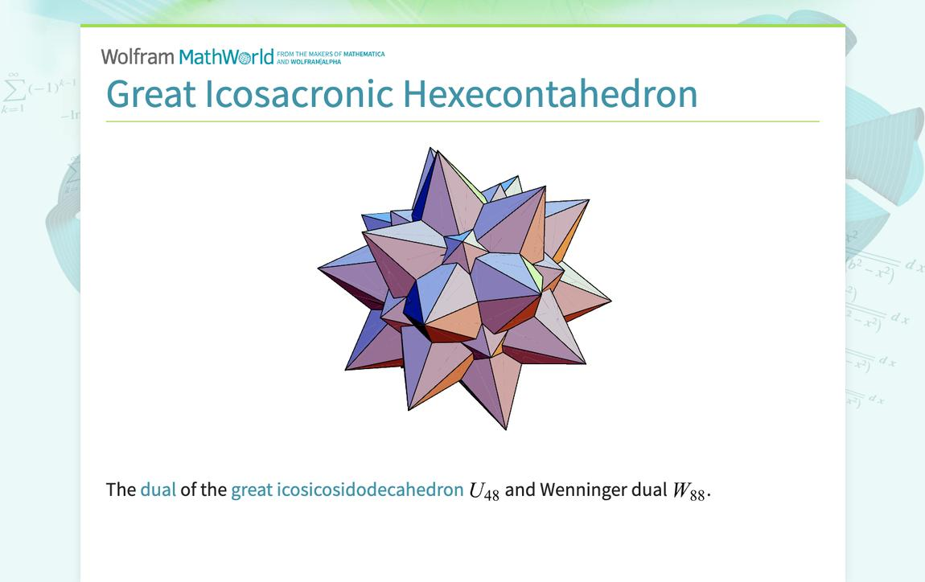
Great Hexacronic Icositetrahedron
The dual polyhedron of the Great Cubicuboctahedron.
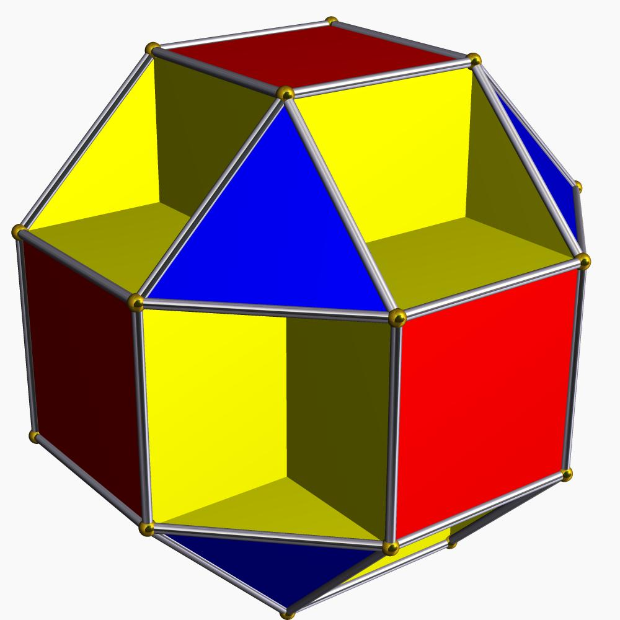
Small Cubicuboctahedron
A related uniform star polyhedron with 8 triangles, 6 squares, and 6 regular octagons instead of octagrams.
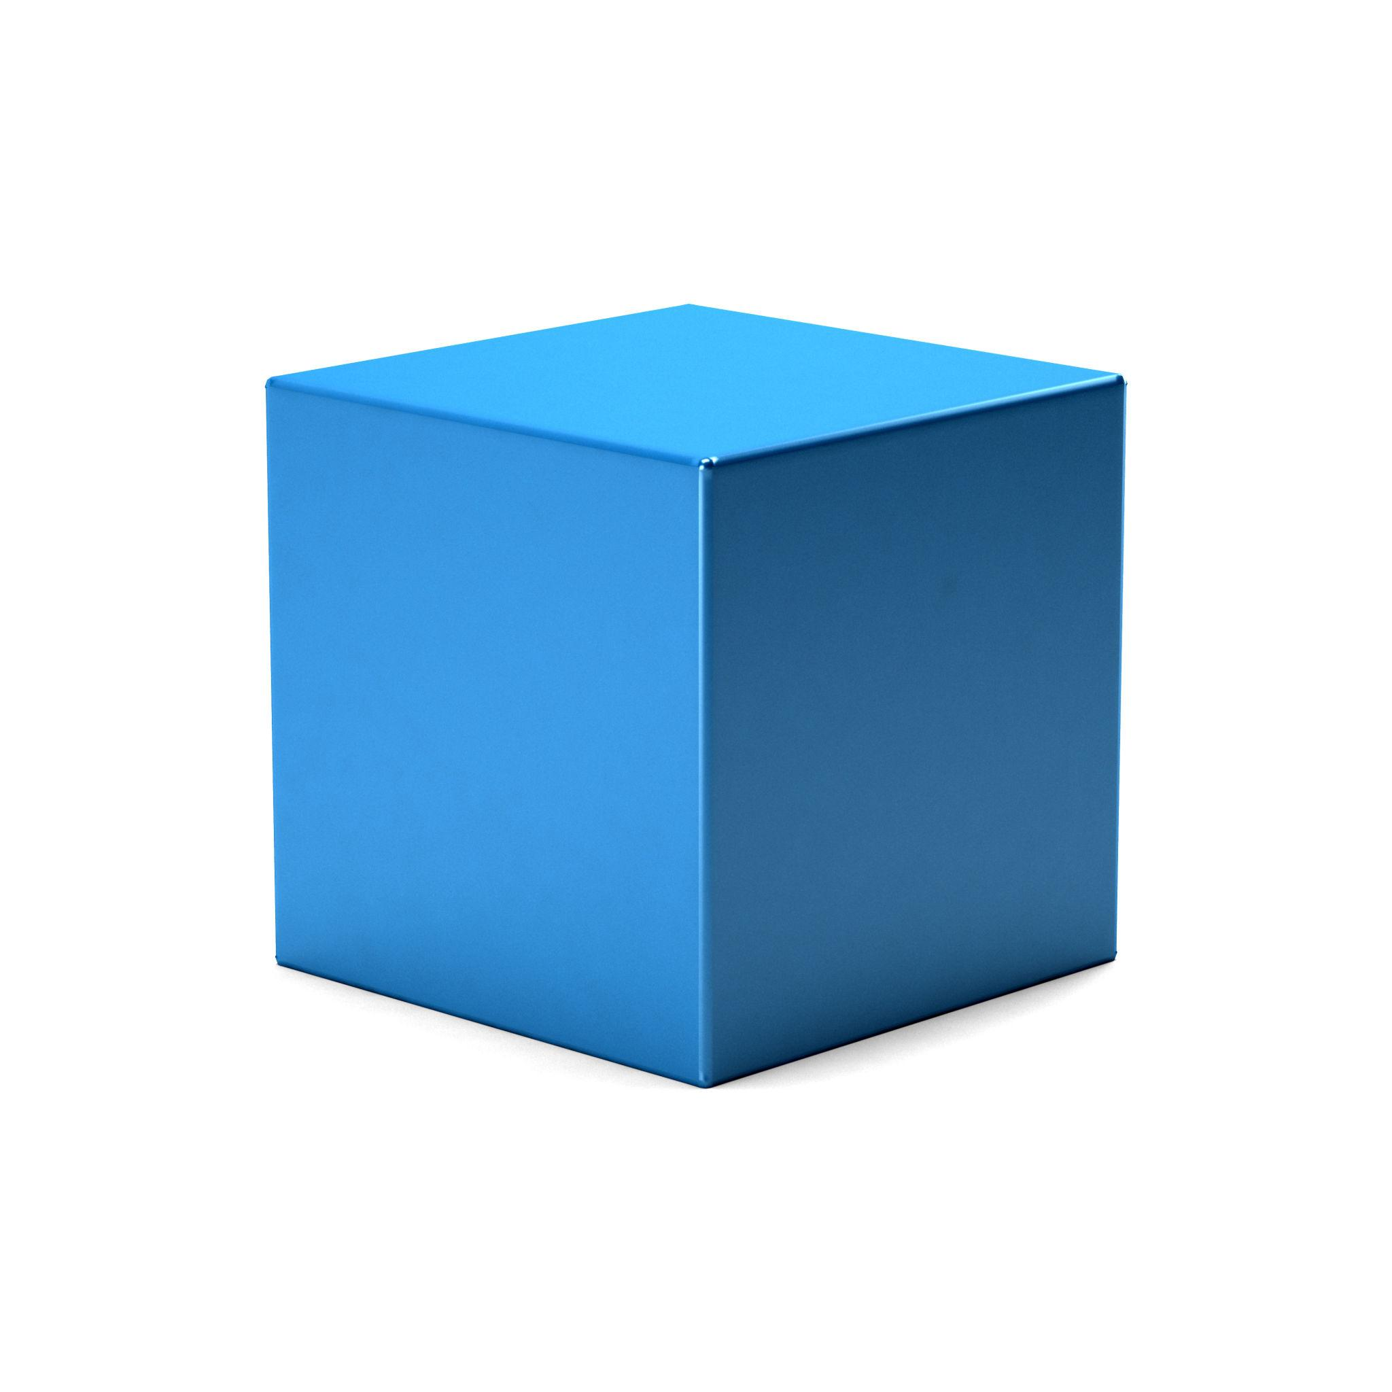
Cube
Provides the fundamental cubic symmetry associated with the Great Cubicuboctahedron's face orientations.

Comparison with Related Uniform Star Polyhedra
# Source: AI Source: Provided by: [Data Path: Persons Table -> ID Column: 1, Name_En Column: Motasem Essam] -> From: [ChatGPT] on [7/25/2026]
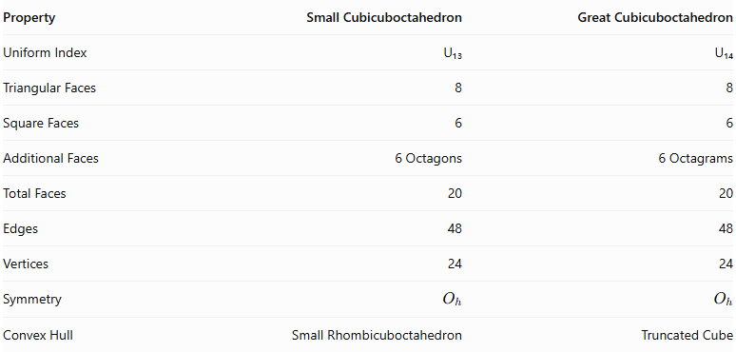
Property | Small Cubicuboctahedron | Great Cubicuboctahedron
Uniform Index | U₁₃ | U₁₄
Triangular Faces | 8 | 8
Square Faces | 6 | 6
Additional Faces | 6 Octagons | 6 Octagrams
Total Faces | 20 | 20
Edges | 48 | 48
Vertices | 24 | 24
Symmetry | $$O_{h}$$ | $$O_{h}$$
Convex Hull | Small Rhombicuboctahedron | Truncated Cube
The main distinction is the additional face type: the Small Cubicuboctahedron uses regular octagons, whereas the Great Cubicuboctahedron uses self-intersecting regular octagrams.

Main Classification
# Source: AI Source: Provided by: [Data Path: Persons Table -> ID Column: 1, Name_En Column: Motasem Essam] -> From: [ChatGPT] on [7/25/2026]
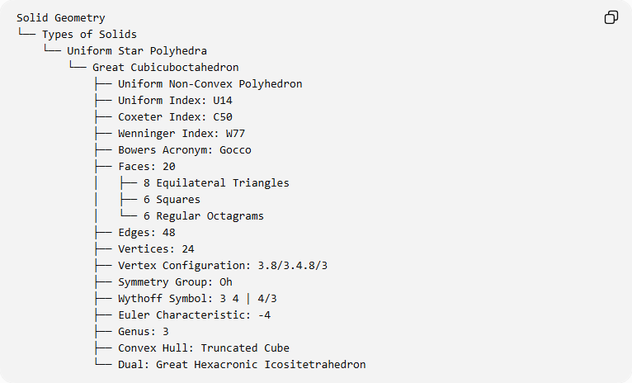
Solid Geometry
└── Types of Solids
└── Uniform Star Polyhedra
└── Great Cubicuboctahedron
├── Uniform Non-Convex Polyhedron
├── Uniform Index: U14
├── Coxeter Index: C50
├── Wenninger Index: W77
├── Bowers Acronym: Gocco
├── Faces: 20
│ ├── 8 Equilateral Triangles
│ ├── 6 Squares
│ └── 6 Regular Octagrams
├── Edges: 48
├── Vertices: 24
├── Vertex Configuration: 3.8/3.4.8/3
├── Symmetry Group: Oh
├── Wythoff Symbol: 3 4 | 4/3
├── Euler Characteristic: -4
├── Genus: 3
├── Convex Hull: Truncated Cube
└── Dual: Great Hexacronic Icositetrahedron

Key Points
# Source: AI Source: Provided by: [Data Path: Persons Table -> ID Column: 1, Name_En Column: Motasem Essam] -> From: [ChatGPT] on [7/25/2026]
- The Great Cubicuboctahedron is a uniform star polyhedron.
- It is classified as U₁₄.
- It has 20 faces: 8 triangles, 6 squares, and 6 octagrams.
- It contains 48 edges and 24 vertices.
- All its edges have equal lengths.
- Its faces intersect to produce a non-convex structure.
- Its symmetry group is $O_{h}$.
- Its Wythoff symbol is $3 4∣4/3$.
- Its convex hull is the truncated cube.
- Its dual is the Great Hexacronic Icositetrahedron.

Conclusion
# Source: AI Source: Provided by: [Data Path: Persons Table -> ID Column: 1, Name_En Column: Motasem Essam] -> From: [ChatGPT] on [7/25/2026]
The Great Cubicuboctahedron is a distinctive uniform star polyhedron characterized by its combination of equilateral triangles, squares, and self-intersecting octagrams. Its 24 vertices, 48 edges, and full octahedral symmetry produce a highly structured non-convex geometry. Its relationship to the truncated cube and the Great Hexacronic Icositetrahedron makes it an important member of the uniform star polyhedra family.

